System Maintenance

System Overview

Graphical User Interface

This part of the system provides the user with an interactable display, making the system more user friendly. It also gives the system a more commercial feel and look. It contains navigational methods via push buttons, making the system simplistic. Input components such as line edits and drop down boxes are included within the interface allowing the user to commit and amend data in the database through the system. The interface displays appropriate labels to allow the user to understand the data that is being displayed.

Home Screen

This area of the system provides the user with a main menu for which they can use to navigate around the program. Each part of the program is selectable via a clearly labelled push button. The user will go through this screen every time they wish to switch areas on the system.

Squad List

This area of the system provides the user with a list of all the players they have previously entered. Each player is selectable if the user wishes to view/amend their details. It also gives the user the option to add a new player or return to the home screen.

Goal List

This area of the system provides the user with a table of all the data on goals that they have previously entered. The data is displayed under clear headers so that it is easy to read and interpret. The user is also given the option to add a new goal or return to the home screen.

Match List

This area of the system provides the user with a table of all the data on matches that they have previously entered. The data is displayed under clear headers so that it is easy to read and interpret. The user is also given the option to add a new match or return to the home screen.

Player Info

This area of the system provides the user with the all the details on a previously selected player. The data is displayed in line edits so that it can be edited. Each line edit is labelled so that the user knows what data is required in each line edit. At the bottom of the screen the user is given the option to save their changes, delete the selected player from the system or cancel (return to the previous screen).

Add Player

This area of the system provides the user with a blank detail screen, the user is prompted to fill in all the line edits with the details required to add a new player to the system. Each one of these line edits will be validated. At the bottom of the screen the user has the option to add the new player to the system and the option to cancel (return to the previous screen).

Add Goal

This area of the system provides the user with two drop down boxes and a line edit, the user is prompted to select an option from the drop down boxes and fill in the line edit with the details required to add a new goal to the system. The line edit will be validated. At the bottom of the screen the user has the option to add the new goal to the system and the option to cancel (return to the previous screen).

Add Match

This area of the system provides the user with a blank detail screen, the user is prompted to fill in all the line edits with the details required to add a new match to the system. Each one of these line edits will be validated. At the bottom of the screen the user has the option to add the new match to the system and the option to cancel (return to the previous screen).

Team Sheet

This area of the system provides the user with a formation to which they can add players to lay out a team for any upcoming matches. Each position is a push button that is clearly labelled, so that it is easy for the user to add a player to the team sheet in a certain position. When a player is entered the position remains a push button so that the player can be swapped. At the bottom of the screen the user has the option to clear the team sheet of all players or return to the home screen.

Player Select

This area of the system provides the user with a list of selectable players (name only), same layout as the squad list, however there is only options to add the selected entry to the team sheet or cancel and return to the team sheet.

Navigation Diagram

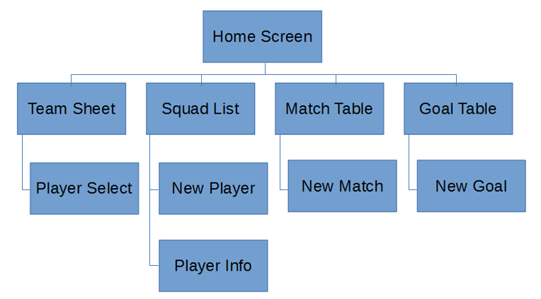

Variable Listing

Home screen

|  |  |
| --- | --- |
| Variable Name | Purpose |
| self.btnTeamSheet | Provides a button for the user to press if they want to go the Team Sheet |
| self.btnSquad | Provides a button for the user to press if they want to go the Squad List |
| self.btnMatch | Provides a button for the user to press if they want to go the Match Table |
| self.btnGoals | Provides a button for the user to press if they want to go the Goal Table |
| self.btnQuit | Provides a button for the user to press if they want to exit the program |
| self.layout | Provides the layout for all the buttons to be displayed on |
| self.team |  |
| Self.squad |  |
| self.match |  |
| self.goals |  |

Squad List

|  |  |
| --- | --- |
| Variable Name | Purpose |
| self.parent | Used to reassign the passed in term |
| self.btnInfo | Provides a button for the user to press if they want to view the Player Info screen |
| self.Home | Provides a button for the user to press if they want to go back to the Home screen |
| self.New | Provides a button for the user to press if they want to add a new Player |
| self.squad_list | Used to display a list of all the players in the database |
| self.VlayoutMain | Provides the main layout for all the screen to be displayed on |
| self.hlayout1 | Provides the secondary layout for all the screen to be displayed on |
| self.widget |  |
| self.new_player |  |
| self.playerInfo |  |
| players | Used as a search term |
| row | Used to sort through the list |
| name_list | Used to temporarily store the Players forename initial and surname |